Norge Linjer Brochure 2011-2012
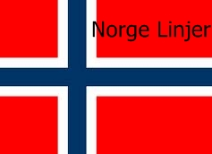

simplifying IT

Norge Linjer Cruises
Norge Linjer proudly announces: Norge Linjer Cruises. A luxury holiday alternative cruising the Baltic and Norwegian Fjords this service is Norge Linjer's most favoured service. We have 3 vessels in current service: NordFjord, MV Scandinavia, and MV Greenland. MV Scandinavia is the longest vessel in our fleet. Her interiors and restaurants are top quality and offer unparalleled tranquillity and luxury at sea. We call at the following ports: Alesund (Home Port), Bergen, Stavanger, Geiranger, Olden, Tromso, North cape, Oslo, Copenhagen, Göteborg, Stockholm, Gdansk, Helsinki, and Oulu.
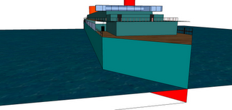
NordFjord
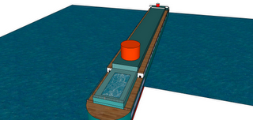

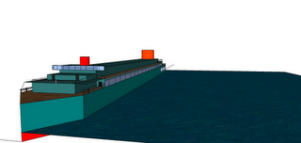
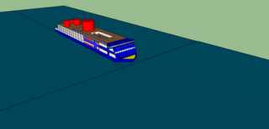
MV Scandinavia 404M long!
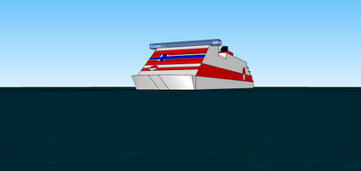
MV Greenland

Voyages:
Here are the voyages running until New Year:
20th Sept-27th Sept: MV Scandinavia
Iteniaery:
Day 1: Boarding at Alesund.
Day 2: Bergen
Day 3: Dundee
Day 4: Sea day
Day 5: Oslo
Day 6: Sea
Day 7: Alesund

30th Sept-9th October: MV Greenland
Day 1: Alesund
Day 2: Geiranger Fjord
Day 3: Olden
Day 4: Sea
Day 5: Tromso
Day 6: Sea
Day 7: North Cape (end of journey)

11th Oct-25th Oct: NordFjord
Day 1: Alesund
Day 2: Sea
Day 3: Sea
Day 4: Reykjavik
Day 5: Sea
Day 6: Sea
Day 7: Sea
Day 8: Nuuk
Day 9: Sea
Day 10: Sea
Day 11: Sea
Day 12: Sea
Day: 13: Sea
Day 14: Alesund
27th Oct – 2 Nov
Day 1: Alesund
Day 2: Trondheim
Day 3: Geiranger
Day 4: Olden
Day 5: Alesund
Cruise Season Ends 2nd Nov for Winter.

